Project on Book Store

--- Basic Questions

1) Retrieve all books in the Fiction Genre

SELECT * FROM Books

WHERE Genre= 'Fiction'
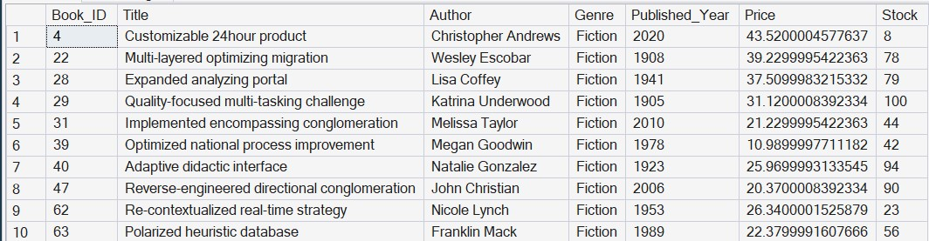

1.1) Count the total no. Of Fiction Genre

SELECT COUNT(*) AS total_Fiction_genre from Books

WHERE Genre= 'Fiction'
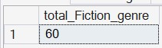

2) Find book published after the year 1950

SELECT * From Books
WHERE Published_year >1950
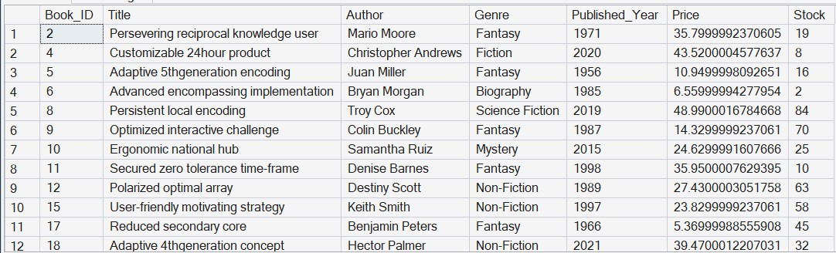

3) List all customer from canada

SELECT * FROM Customers
WHERE Country = 'Canada'
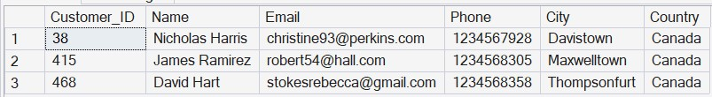

4) Show orders placed in nov 2023

SELECT * FROM Orders

WHERE Order_Date BETWEEN '2023-11-01' AND '2023-11-30'
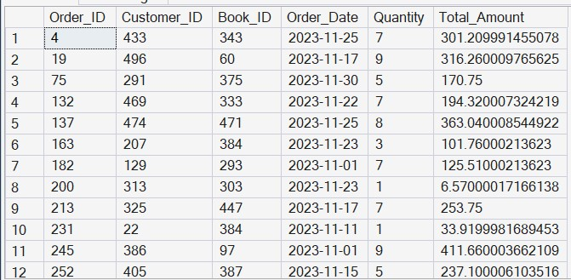

5) Retrieve the total amount of books available

SELECT SUM(Stock) AS Total_stock
From Books
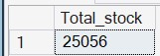

6) Find the details of the most expensive books

SELECT TOP 1 * FROM Books ORDER BY Price DESC

7) Show all customer who order more than 1 quantity of a book

SELECT * FROM Orders
WHERE Quantity >1
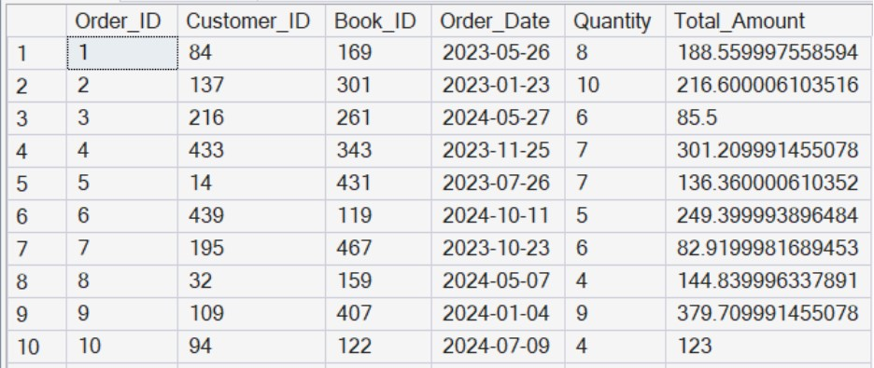

8) Retrieve all order where the total amount exceed 20$

SELECT * FROM Orders
WHERE Total_Amount >20
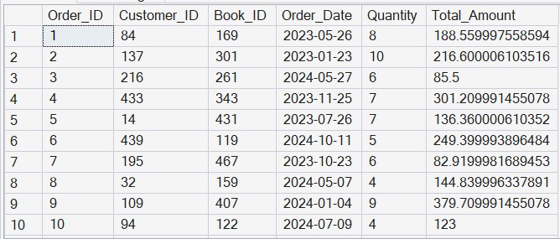

9) List all genre available in the book genre

SELECT DISTINCT Genre FROM Books
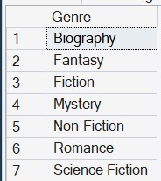

10) Find the book with the lowest stock

SELECT TOP 1 * FROM Books ORDER BY Stock ASC

11) Calculate the total revenue generated from all orders

SELECT SUM(Total_Amount) AS total_revenue
FROM Orders
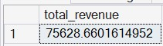

----Advanced Query

1) Total no. of books sold on each genre

SELECT b.Genre, SUM(Quantity)AS total_sold_genre
FROM orders o
JOIN Books b
ON b.Book_ID = o.Order_ID

GROUP BY b.Genre
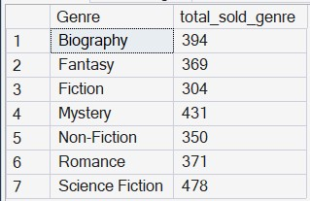

2) Find avg price of books in the 'Fantasy' genre

SELECT AVG(price) AS avg_price
FROM Books

WHERE Genre = 'Fantasy'
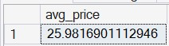

3) List customers who have placed at least 2 orders

SELECT o.Customer_ID, c.name, COUNT(o.order_id) AS order_count
FROM orders o
JOIN customers c
ON o.Customer_ID = c.Customer_ID
GROUP BY o.Customer_ID, c.name
HAVING COUNT (order_id) >=2
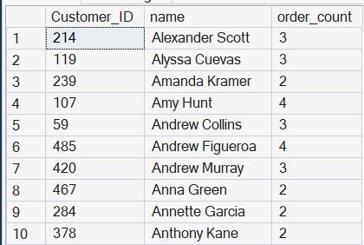

4) Findthe most frequently ordered book

SELECT TOP 2
o.Book_id, b.title, COUNT (O.Order_id) AS order_count
FROM Orders o
JOIN Books b
ON o.Book_ID = b.Book_ID
GROUP BY o.Book_ID, b.Title
ORDER BY order_count DESC
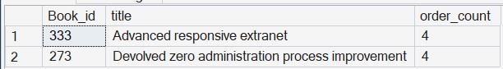

5) Show the top 3 MOST expensive books of 'Fantasy' Genre

SELECT TOP 3 * FROM Books

WHERE Genre ='Fantasy'

ORDER BY Price DESC
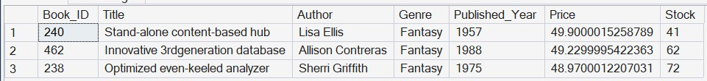

6) Retrieve the total quantity of books sold by each author

SELECT b.Author , SUM (Quantity) AS Total_sold_books
FROM orders o
JOIN Books b
ON b.Book_ID = o.Order_ID
GROUP BY b.Author
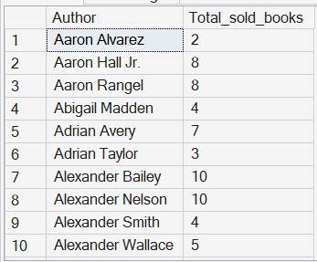

7) List the cities where customer who spent the most on orders

SELECT c.city, o.total_amount
FROM Customers c
JOIN Orders o
ON c.Customer_ID = o.Customer_ID
WHERE Total_Amount > 30
ORDER BY Total_Amount DESC
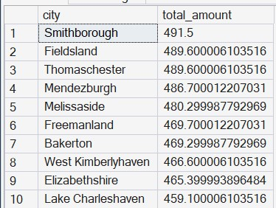

8) Find the customer who spent the most on orders

SELECT TOP 1 c.*, o.quantity
FROM Customers c
JOIN Orders o
ON c.Customer_ID = o.Customer_ID

ORDER BY Quantity DESC

9) Calculate the stock remaining after fulfilling all orders

SELECT b.book_id, b.title, b.stock, COALESCE(SUM(o.quantity),0) AS order_quantity, b.stock-COALESCE(SUM(o.quantity),0) AS remaining_quantity
FROM Books b
LEFT JOIN Orders O
ON b.Book_ID = o.Book_ID
GROUP BY b.Book_ID,b.title, b.stock
ORDER BY b.Book_ID

